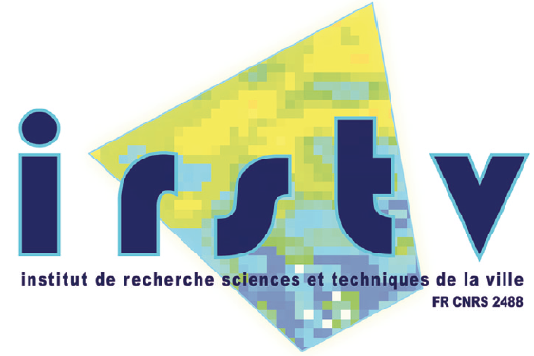

Postdoctoral position 1 - Modelling and evaluation of the influence of vegetation on urban microclimate

A postdoctoral position is available for 12 months at the Institute of Research in Urban Sciences and Techniques (IRSTV). The candidate will join the team Dynamics of Urban and Coastal Atmosphere of the LHEEA (Hydrodynamics, Energetic and Atmospheric Environment laboratory, Ecole Centrale Nantes, France). The work will be done in close collaboration with the team Functional Ecology and Environmental Physics (EPHYSE) of the French Research Institute in Agronomy (INRA, Bordeaux, France).

In the framework of the VegDUD ANR project, we intend to assess the influence of some urban vegetation devices on urban microclimate. A multilayer urban canopy model based on a drag-force approach has been introduced in the atmospheric model ARPS in order to simulate the momentum and heat turbulent transfers between the canopy and the atmosphere. The inclusion of moisture transfers due to the presence of vegetation within the urban canopy layer is in progress. Based on scenarios of evolution of the city of Nantes (France) that take into account both the urban form and green devices, the postdoctoral researcher will be in charge of defining the configurations of simulations which enable a quantitative assessment of the microclimate modification (in terms of temperature and humidity) due to various vegetation devices. Since the study concerns scales ranging from the city to the neighborhood scale, the objective is also to evaluate which spatial arrangement of these devices (green roofs, parks…) is the most efficient and what is the degree of expansion required to have significant microclimatological impact.

The candidate should have a PhD degree (before September 2012) and a recognized experience in numerical modeling of the atmospheric boundary layer and/or canopy-atmosphere interactions. Sense of initiative, organization and relational qualities, as well as a basic knowledge of French language, with capacity to read French technical and scientific literature will be highly appreciated.

The beginning of the work is planned in October 2012. The gross pay is 2500€/month and the employer is CNRS.
Contact: Isabelle.Calmet@ec-nantes.fr and Sylvain.Dupont@bordeaux.inra.fr
Postdoctoral position 2 - Modelling the impact of vegetation on buildings’ energy consumption at district scale.

A post-doctoral position is available for 12 months at the Institute of Research in Urban Sciences and Techniques (IRSTV). The work will be done in close collaboration with 3 teams: CERMA laboratory (ensa Nantes), GEPEA (Ecole des Mines de Nantes) and LHEEA (Ecole Centrale de Nantes).

In the framework of VegDUD project, funded by French Research Agency, we intend to assess the influence of several green set-ups (green walls and roofs, lawns, trees) on buildings’ energy consumption at district scale. http://www.irstv.fr/index.php?option=com_content&view=article&id=34%3Aanr-villes-durables-2009&catid=7%3Aen-cours&Itemid=63&lang=fr

The work will be based on the results of several previous works:
- The doctoral thesis prepared by Laurent Malys (CERMA) which will produce the knowledge of direct (insulation and shading) and indirect impacts (climate modification) obtained when applying the green set-ups in a residential district;
- The doctoral thesis prepared by David Garcia-Sanchez (GEPEA) that will provide the sensibility analysis of a thermal model to construction parameters;
- The other numerical or experimental results of studies that are carried out in the frame of the project (doctoral theses prepared by Rabah Djedjig and Adrien Gros at LaSIE laboratory and by Magdalena Maché at LHEEA laboratory) will complete this knowledge at different scales.

Starting from these works, the candidate will have to:
- clarify how to characterize and parametrize the direct and indirect impacts of vegetation set-ups,
- propose solution to modify the input data used in thermal models so that to take these impacts into account;
Then, using one or several models developed within the project, the developments made by the candidate will be applied to assess the energy consumption related to a district for several configurations:
- present situation,
- its evolution in a densification case without adding vegetation,
- its evolution in a densification case with several greening scenarios.
Uncertainties will be assessed and the simulated buildings’ energy consumptions obtained for present situation will be compared with measures, if available.

The beginning of the work is planned in October 2012. The gross pay is 2500€/month and the employer is CNRS.

The candidate should have a PhD degree (before September 2012) and a recognized experience in buildings energy simulation. Sense of initiative, organization and relational qualities, as well as a basic knowledge of French language, with capacity to read French technical and scientific literature will be highly appreciated.

Contacts:
Marjorie Musy: Marjorie.musy@cerma.archi.fr
Bernard Bourges: Bernard.Bourges@mines-nantes.fr

Postdoctoral position 3 - Assessment of the impact of greening scenarios on comfort at district scale.

A post-doctoral position is available for 12 months at the Institute of Research in Urban Sciences and Techniques (IRSTV). The candidate will join the team CERMA (School of architecture of Nantes).

In the framework of VegDUD project, funded by French Research Agency, we intend to assess the influence of several green set-ups (green walls and roofs, lawns, trees) on thermal comfort at district scale. http://www.irstv.fr/index.php?option=com_content&view=article&id=34%3Aanr-villes-durables-2009&catid=7%3Aen-cours&Itemid=63&lang=fr

The work will be based on the results of several previous works:
- The doctoral thesis prepared by Laurent Malys (CERMA) which will produce the knowledge of direct (insulation and shading) and indirect impacts (climate modification) obtained when applying the green set-ups in a residential district;
- The previous works carried out in the CERMA laboratory (doctoral theses defended by Mirela Robitu and Jerome Vinet)

Starting from these works, the candidate will have to study the comfort conditions in a district for several configurations:
- the present situation;
- several greening scenarios in a denser situation;
Then he (she) will conclude about the relative efficiency of the different settings and on the processes (direct and indirect impacts) that contribute the most to thermal comfort.

The beginning of the work is planned in October 2012. The gross pay is 2500€/month and the employer is CNRS.

The candidate should have a PhD degree (before September 2012) and a recognized experience in thermal comfort assessment and in microclimate simulation. Sense of initiative, organization and relational qualities, as well as a basic knowledge of French language, with capacity to read French technical and scientific literature will be highly appreciated.

Contact:
Marjorie Musy : Marjorie.musy@cerma.archi.fr

